Tips for how to choose the right running shoe
- If it hurts or rubs out of the box, ditch it

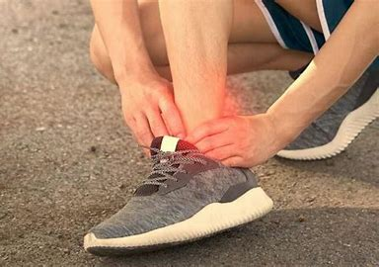
If you immediately put a new shoe on and feel it rubbing, poking, pinching, etc. this is a sign that it’s not the right fit for you. Don’t tell yourself it will stretch out over time or your foot will adjust. The right shoe will feel good right out of the box and continue to get even more comfortable as you get used to the shoe.
- Have a gait analysis done so you can determine what your feet and ankles do when you walk and run
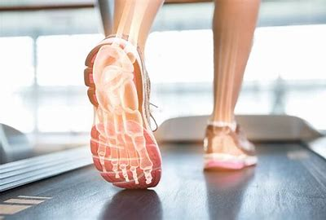

Potential findings include:
-Excessive pronation= When your foot rolls in excessively, placing increased strain on the inside ankle muscles and arch. This can lead to injuries such as shin splints, achilles tendonitis and knee and hip injuries. Look for higher support shoes that increase ground contact time and stability and reduce the amount of pronation in your foot during toe off.
-Neutral= Look for a moderate support shoe with little to no motion control and moderate to minimal cushion- This type of gait pattern allows for more flexibility in shoe choices.
-Excessive supination=When your foot rolls out excessively, placing increased strain on the outside ankle muscles leading to decreased shock absorption and increased risk of injuries such as ankle sprains and shin splints. Look for a shoe with Moderate stability and cushioning
- Shoe sizing matters
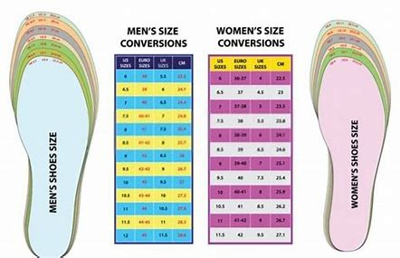
Remember, when you run your feet will begin to swell and that shoe that originally fit perfect may be feeling awfully tight by the end of your run. For this reason, the general recommendation is to leave at least 1-2 inches at the end or go up a half size depending on the brand
Do you have wide, normal or narrow feet? Everyone’s foot is different, and you want to match your shoe accordingly. Trying to force a wide foot into a narrow shoe will only cause pain and gait deviations, so make sure you get a shoe that fits your foot instead of forcing your foot into a shoe you think is cute or on sale.
- No slipping or sliding
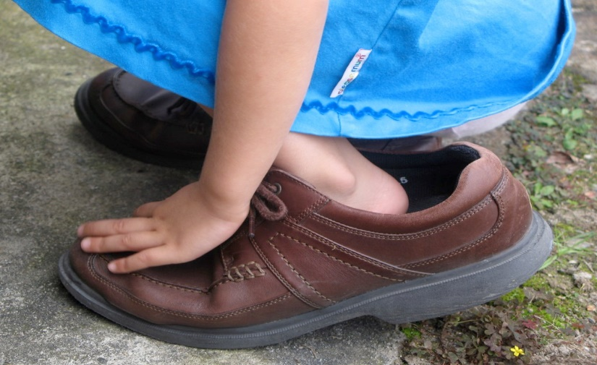
Pay attention to the fit of the shoe- Do your feet slide around at all? Does your heel rub or feel unsteady in the shoe? You want to make sure the shoe feels snug, but not too tight and provides good support and stability around your heel and through your arch to promote proper arch lifting and flattening during the gait cycle
- Make sure your toes have room to splay and spread
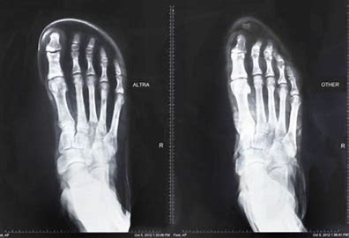

Pay attention to your toes- do they feel scrunched up? Are they pushing against the top or sides of the shoe? You want to make sure the end or toe box of your shoe provides enough space for all your toes to make contact with the ground, ideally even leaving room for those toes to spread and push into the ground as you push off the ground. If you have a wider foot, you will want to look for a shoe that has a wider toe box to match and vice versa for a more narrow foot.
- Make sure the shoe can bend and twist in the right places
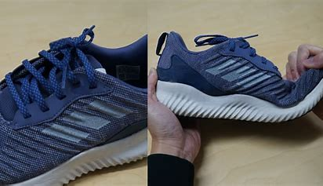
In order for your toes to get proper push off, your shoe needs to be flexible in the right spot. An easy way to check this to hold your shoe with your heel in one hand and the toe in the other. Gently push the toe box up and look to see where the shoe creases. We want that crease to fall in the same place where your toes bend during push off. If this crease is too far forward or back, it will cause discomfort and may alter the way you push off the ground. Another component of a good shoe is its ability to supinate and pronate, allowing your foot to also perform these movements during the gait cycle. To test this out, again grip the heel of your shoe in one hand and the toe box in the other. Gently twist the toe inward as you twist the heel outward. Perform the same movement but in the opposite direction. Notice how much the shoe can move in these directions. Too much movement means risking increased supination or pronation, not enough means your foot will likely not access it’s full range of motion which will impact your ability to properly land and push off.
- Cushion for the pushin
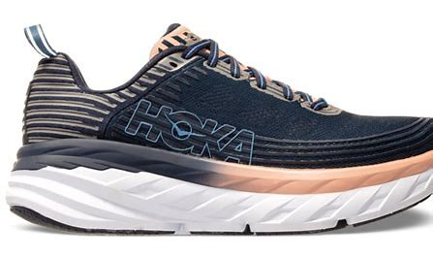
Many people gravitate towards shoes that feel soft under foot and provide a lot of cushioning. While having some cushioning can be helpful to provide comfort and reduce the impact of force traveling through your foot when you land, too much cushioning can be a problem. Research shows that the more cushioning a runner has on their shoe, the harder they tend to land. Additionally, evidence has shown that your joints will absorb most of the force by using the built-in cushioning we are created with. However, this means those with certain degenerative conditions and previous injuries may need more external cushioning from the shoe itself due to lacking the cushioning their joints normally have.
- Drop it like it’s hot
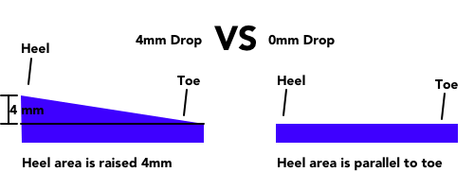

You may have heard the term “drop” thrown around in reference to your shoes before, but not really known what that means. Basically, drop is the height difference between the heel and toe of the shoe and impacts how your foot will strike the ground. For example, a zero-drop shoe means there is no difference between these two points and an equal amount of cushioning on the heel and toe areas. This type of shoe will promote more of a mid-strike landing position, which is thought to reduce the overall impact compared to a heel strike. However, a lower drop shoe will put more strain on your Achilles tendon, as it will be in a more lengthened position during landing.
Traditional running shoes have a heel drop of around 10 mm or more, as this encourages landing on your heel first, allowing you to better utilize your ankle rockers to move from heel to toe. While experts remain divided on what the “right” amount of drop is, they do agree that the amount of drop will have an impact on the amount of force distribution to the foot and leg, as well as change your stride. General recommendation is to start in a more “traditional” drop shoe, and if you want to move into less drop, do so slowly and over a longer period to allow your foot and ankle to adjust.

